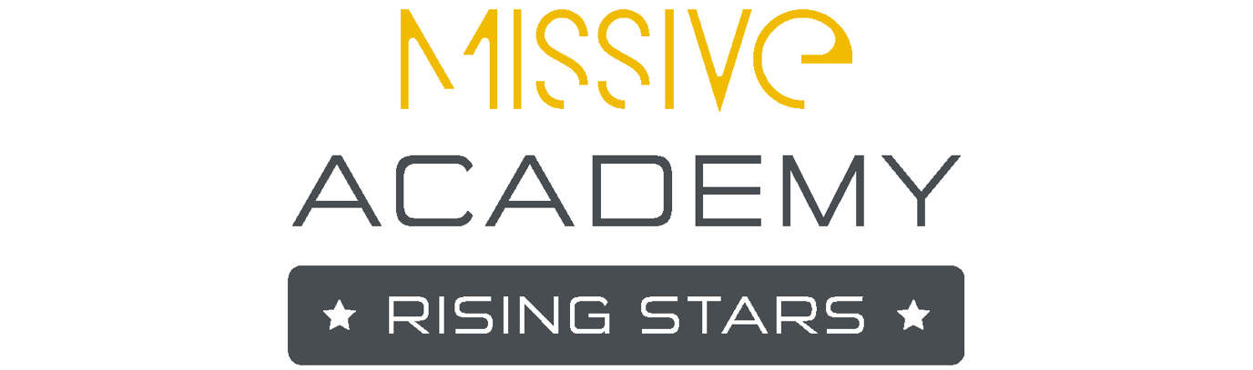

Missive Academy Rising Stars
Application Form

Thank you for your interest in MARS. Once you’ve completed all the questions below, please email your form to hello@missive.co.uk. We’re excited to receive your application!

As a reminder, the eligibility criteria asks that:
- You are based in the UK
- You are a school leaver, are in your final year or have graduated from further-education studies, or are considering a career change
- You are new to the PR industry and have not been employed in full or part-time capacity a PR role in the past or, at most, have completed work experience or an internship in PR.

We are passionate about supporting the next generation of PR professionals to enter the industry and particularly encouraging much-needed diversity in our sector.

Full Name |  | Date of application
Email Address |  | Contact number

Please provide a short statement (no more than 200 words) on why you are applying for the MARS programme. We will be using this to assess your writing skills and interest in a PR career.

Please highlight what age bracket you are in:
- 18-25
- 26-35
- 36-45
- 46-55
- 56-65
- 66 and over

Please highlight whether you’ve had experience of any of the following. Select as many as apply to your experience:
- Work experience placement
- PR internship
- PR apprenticeship
- Volunteer work
None
- Other, please specify:

What gender do you most identify with?:

What are your preferred pronouns?:

Do you have the right to work in the UK? Highlight one:
- Yes
- No

How would you best describe your racial or ethnic origin?:

If you feel comfortable sharing, do you identify with any of the following protected characteristics? Highlight any that apply:
- LGBTQIA+
- Historically marginalised ethnicity
- Physical disability
- Neuro-diversity
- Low socio-economic background
- Part of a religious community
- Carer
- None
- I’d rather not say
- Other, not included here. Please specify

Do you have any accessibility requirements or commitments we need to be aware of?:

Please highlight the highest level of education you have received:
- Doctorate/Masters/Post Grad/Level 7 or 8 NVQ or Diploma
- Degree/Level 5 or 6 NVQ or Diploma
- Higher Apprenticeship/CertHE, Level 4 NVQ or Diploma
- A level/AS level/Advanced Apprenticeship/Level 3 NVQ or Diploma /T level
- GCSE/Intermediate Apprenticeship/Level 1 or 2 NVQ or Diploma
- Other or educated outside of the UK - please specify:

Please highlight how you find out about the programme:
- LinkedIn
- Personal referral
- Creative Access
- PRCA
- Other, please specify:

Please indicate which intake/s you could attend. If you can only do one intake, then please only select this – highlight all that apply:
- March
- April
- May
- No preference, I can attend all
- I can’t attend these months, but am interested in dates later in the year

-------------------------------------------------------------------------------------------------------

By submitting this application, I understand that:

- I am committing to 8-10 hours of personal development.
- I have not worked full-time in the PR industry before.
- That failure to complete any of the sessions offered may mean I may be removed from the programme.
- Submitting false information on this form may result in my removal from the programme.

Signed:

Date:

-------------------------------------------------------------------------------------------------------

Data Usage and Retention Policy
Missive is committed to ensuring the privacy and security of your personal data. For more information about how we collect, use, and store your data in compliance with the General Data Protection Regulation (GDPR) please ask us via hello@missive.co.uk and we can share more detail.

